**Myriad of opportunities in Zim’s mining sector**

http://www.miningweekly.com/article/myriad-of-opportunities-in-zimbabwes-mining-sector-2017-09-08/rep_id:3650

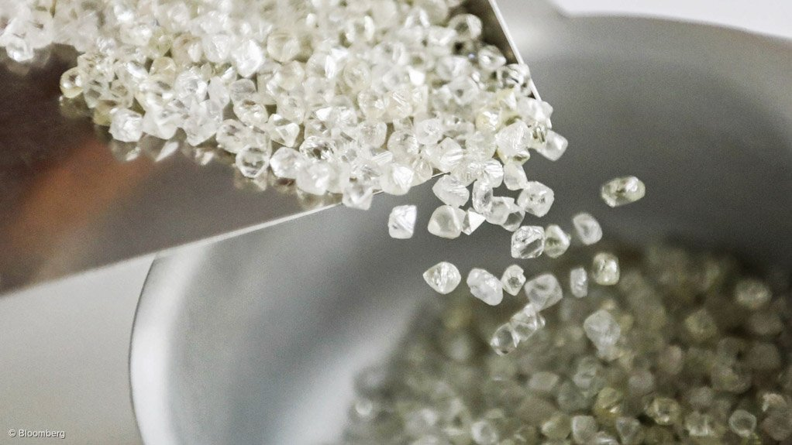

**Photo by** Bloomberg  
DIAMONDIFEROUS Zimbabwe has deposits of high-quality diamonds, which are in high demand on the global market

8TH SEPTEMBER 2017

[Zimbabwe](http://www.miningweekly.com/topic/zimbabwe) is poised for growth and, with the country committed to ensuring a [sustainable](http://www.miningweekly.com/topic/sustainable) growth path, there is a host of investment opportunities in the [mining](http://www.miningweekly.com/topic/mining) industry to be capitalised on.

This is according to the investment promotion body [Zimbabwe](http://www.miningweekly.com/topic/zimbabwe) Investment Authority’s Invest in [Zimbabwe](http://www.miningweekly.com/topic/zimbabwe)Handbook 2017, published in March.

The handbook, compiled by the Ministry of Macro-Economic Planning and Investment Promotion, and the [Zimbabwe](http://www.miningweekly.com/topic/zimbabwe)Economic Policy Analysis and Research Unit, aims to provide critical information to prospective investors in [Zimbabwe](http://www.miningweekly.com/topic/zimbabwe), as a way of enhancing the country’s [business](http://www.miningweekly.com/topic/business) [environment](http://www.miningweekly.com/topic/environment).

[Zimbabwe](http://www.miningweekly.com/topic/zimbabwe) boasts the largest concentration of mineral deposits in the world, along the [Great Dyke](http://www.miningweekly.com/topic/great-dyke) corridor, a linear geological feature that extends more than 550 km north-east to south-west across the centre of the country. The [Great Dyke](http://www.miningweekly.com/topic/great-dyke) hosts the world’s second-largest reserve of [platinum](http://www.miningweekly.com/topic/platinum)-group metals and also harbours other rich mineral occurrences, the handbook indicates.

There are more than 40 different minerals present in [Zimbabwe](http://www.miningweekly.com/topic/zimbabwe), with the country hosting [diamonds](http://www.miningweekly.com/topic/diamonds), [platinum](http://www.miningweekly.com/topic/platinum), [gold](http://www.miningweekly.com/topic/gold), nickel, [copper](http://www.miningweekly.com/topic/copper), [iron-ore](http://www.miningweekly.com/topic/iron-ore-person), zinc, chromium ores, asbestos, vanadium, lithium, tin and [coal](http://www.miningweekly.com/topic/coal) to name a few. With regard to [gold](http://www.miningweekly.com/topic/gold), the country has over 4 000 recorded deposits, 90% of which are associated with greenstone belts that are some of the richest in the world, the handbook highlights.

Moreover, [Zimbabwe](http://www.miningweekly.com/topic/zimbabwe) also has deposits of high-quality [diamonds](http://www.miningweekly.com/topic/diamonds), which are in high demand on the global market and is home to the second-largest diamond reserve in the world.

[Zimbabwe](http://www.miningweekly.com/topic/zimbabwe) can further lay claim to eight of the nine rare-earth minerals as well as having the capacity to process [gold](http://www.miningweekly.com/topic/gold), [diamonds](http://www.miningweekly.com/topic/diamonds) and chrome. The country also has the largest known chrome ore [resources](http://www.miningweekly.com/topic/resources) in the world.

[Zimbabwe](http://www.miningweekly.com/topic/zimbabwe) also exports about 166 000 m3 of raw granite yearly, with mineral exports accounting for over 50% of its foreign [export](http://www.miningweekly.com/topic/export) earnings and the minerals sector contributing about 16% of the country’s [gross domestic product](http://www.miningweekly.com/topic/gross-domestic-product).

The handbook details that unfettered exports from [Zimbabwe](http://www.miningweekly.com/topic/zimbabwe) are authorised for all goods, save for those that are of national interest – including the [export](http://www.miningweekly.com/topic/export) of wildlife, hides and minerals.

[Zimbabwe](http://www.miningweekly.com/topic/zimbabwe)’s rich mineral [resources](http://www.miningweekly.com/topic/resources) base presents lucrative opportunities for [exploration](http://www.miningweekly.com/topic/exploration), [mining](http://www.miningweekly.com/topic/mining) and beneficiation, posits the handbook.

The country presents vast opportunities for kimberlitic diamond discoveries, with over 150 kimberlites having being discovered to date.

[Zimbabwe](http://www.miningweekly.com/topic/zimbabwe) is estimated to have more than 20-trillion cubic feet of quality [coal](http://www.miningweekly.com/topic/coal)-bed methane (CBM) available for [exploration](http://www.miningweekly.com/topic/exploration) and production. There are over 26-billion tonnes of coals reserves. The Hwange area has large reserves of both coking and thermal [coal](http://www.miningweekly.com/topic/coal). Despite the widespread occurrence of [coal](http://www.miningweekly.com/topic/coal) in the country, development and production has so far been confined to Hwange, with potential for more [exploration](http://www.miningweekly.com/topic/exploration) and production beyond the area, notes the handbook.

**Opportunities by Mineral**

In terms of minerals [exploration](http://www.miningweekly.com/topic/exploration) and extraction, investment opportunities exist in [gold](http://www.miningweekly.com/topic/gold), [coal](http://www.miningweekly.com/topic/coal), CBM, chrome, black granite and [diamonds](http://www.miningweekly.com/topic/diamonds). These opportunities include new [project](http://www.miningweekly.com/topic/project)development, the resuscitation of closed mines, such as the Sabi [gold](http://www.miningweekly.com/topic/gold) mine, in Zvishavane, which restarted [operations](http://www.miningweekly.com/topic/operations) at the start of this year; and the Kamativi tin mine, in Matabeleland North, and recapitalisation of lithium and nickel mines.

Value-addition investment opportunities exist in the [lithium chemicals](http://www.miningweekly.com/topic/lithium-chemicals) and lithium batteries industries, the [cement](http://www.miningweekly.com/topic/cement)industry in terms of limestone, [gold](http://www.miningweekly.com/topic/gold) jewellery [manufacturing](http://www.miningweekly.com/topic/manufacturing), the [construction](http://www.miningweekly.com/topic/construction) and dimensional stone polishing industries in terms of black granite, and the [cutting](http://www.miningweekly.com/topic/cutting) and polishing, and [jewellery manufacturing industries](http://www.miningweekly.com/topic/jewellery-manufacturing-industries) in relation to [diamonds](http://www.miningweekly.com/topic/diamonds), [gemstones](http://www.miningweekly.com/topic/gemstones) and semiprecious stones.

Potential also exists in [steel](http://www.miningweekly.com/topic/steel) [manufacturing](http://www.miningweekly.com/topic/manufacturing) using [iron-ore](http://www.miningweekly.com/topic/iron-ore-person), nickel and chrome; the conversion of [coal](http://www.miningweekly.com/topic/coal) to liquid fuel and the use of [coal](http://www.miningweekly.com/topic/coal) in [electricity generation](http://www.miningweekly.com/topic/electricity-generation) or domestic consumption and [export](http://www.miningweekly.com/topic/export). The handbook also notes [cement](http://www.miningweekly.com/topic/cement)and brick [manufacturing](http://www.miningweekly.com/topic/manufacturing) using ash from combusted [coal](http://www.miningweekly.com/topic/coal). Further, phosphate and CBM opportunities with regard to [fertiliser manufacturing](http://www.miningweekly.com/topic/fertiliser-manufacturing) are highlighted, as are [platinum](http://www.miningweekly.com/topic/platinum)[refining](http://www.miningweekly.com/topic/refining) and [chrome ore processing](http://www.miningweekly.com/topic/chrome-ore-processing).

**Opportunities by Province**

In [Harare](http://www.miningweekly.com/topic/harare), opportunities exist for investors in quarry stone [mining](http://www.miningweekly.com/topic/mining) with regard to [road](http://www.miningweekly.com/topic/road) [building](http://www.miningweekly.com/topic/building) and [maintenance](http://www.miningweekly.com/topic/maintenance), [mining](http://www.miningweekly.com/topic/mining) and [asphalt](http://www.miningweekly.com/topic/asphalt) [manufacturing](http://www.miningweekly.com/topic/manufacturing) for [roads](http://www.miningweekly.com/topic/roads), as well as in [mining](http://www.miningweekly.com/topic/mining)-related [manufacturing](http://www.miningweekly.com/topic/manufacturing).

In Manicaland, opportunities exist in [gold](http://www.miningweekly.com/topic/gold) and [diamond mining](http://www.miningweekly.com/topic/diamond-mining), as well as in diamond [cutting](http://www.miningweekly.com/topic/cutting) and polishing.

Meanwhile, in Masvingo, [mining](http://www.miningweekly.com/topic/mining) of lithium, which is being undertaken by [lithium producer](http://www.miningweekly.com/topic/lithium-producer) [Bikita Minerals](http://www.miningweekly.com/topic/bikita-minerals), is highlighted, as well as tantalite, [coal](http://www.miningweekly.com/topic/coal), [iron-ore](http://www.miningweekly.com/topic/iron-ore-person), [gold](http://www.miningweekly.com/topic/gold), limestone and chrome. Opportunities in beneficiation and value addition are also noted.

Midlands presents investors with opportunities in prospecting for [gold](http://www.miningweekly.com/topic/gold), [coal](http://www.miningweekly.com/topic/coal), [diamonds](http://www.miningweekly.com/topic/diamonds), granite and [platinum](http://www.miningweekly.com/topic/platinum). There is also potential to rehabilitate steelworks entity [Zimbabwe Iron & Steel Company](http://www.miningweekly.com/topic/zimbabwe-iron-steel-company) and [ferrochrome producer](http://www.miningweekly.com/topic/ferrochrome-producer)[Zimbabwe Alloys](http://www.miningweekly.com/topic/zimbabwe-alloys) furnaces, as well as reopen the Shabanie asbestos mine.

In Mashonaland East, [gold](http://www.miningweekly.com/topic/gold), black granite and limestone prospecting opportunities exist, as does potential to establish processing plants.

Further, Mashonaland Central is highlighted for its [gold](http://www.miningweekly.com/topic/gold) ore customer milling centres and chrome smelter prospects.

[Exploration](http://www.miningweekly.com/topic/exploration) opportunities are noted in Mashonaland West, as are [gold](http://www.miningweekly.com/topic/gold), chrome, [platinum](http://www.miningweekly.com/topic/platinum), [copper](http://www.miningweekly.com/topic/copper), manganese and [coal](http://www.miningweekly.com/topic/coal)[mining](http://www.miningweekly.com/topic/mining). Other prospects are presented by the beneficiation of [gold](http://www.miningweekly.com/topic/gold), [platinum](http://www.miningweekly.com/topic/platinum), chrome, [copper](http://www.miningweekly.com/topic/copper), nickel, manganese and [coal](http://www.miningweekly.com/topic/coal).

Matabeleland North, where the Kamativi tin mine is opening, offers the prospecting and [mining](http://www.miningweekly.com/topic/mining) of various minerals, quarrying, [gold](http://www.miningweekly.com/topic/gold) deposits in the Bubi and Umguza districts, coke processing in Hwange and [methane gas](http://www.miningweekly.com/topic/methane-gas) in Lupane. Lastly, opportunities exist to operate haulage [trucks](http://www.miningweekly.com/topic/trucks) to ferry [coal](http://www.miningweekly.com/topic/coal) from Hwange.

Matabeleland South also has various mineral occurrences, some of which have not been explored. It also offers opportunities in [gold](http://www.miningweekly.com/topic/gold) with regard to resuscitating existing mines, prospecting and the establishment of new mines. Five of the sevens districts in Matabeleland South host [gold](http://www.miningweekly.com/topic/gold)deposits. There are also opportunities involving artisanal miners; if properly equipped and capacitated to remit communal share ownership trusts, indicates the handbook, noting lastly, the potential to create value-addition and beneficiation centres in the province.